 | 12 Enterprise Computing: Unit 1 Data Science  Practical Exercise (not for formal assessment)  Creating a Relational Database Quest Theme Park
This activity is designed to be a helpful walk through for your Assessment Task 1. When you have done this task, you should be able to use your own set of data to create your spreadsheet, relational database and data dashboard for the assessment task.

You are a data scientist who has been asked by the owners of a new theme park to create their customer database. Quest Theme Park is a new park located near the Western Sydney Internation Airport. It is likely to attract many visitors from NSW and overseas. It has many rides from simple roundabouts to white knuckle roller coasters. It is divided into three zones – Aquatica, Destiny and Mini Quest. A fourth zone is under construction and will be opening for the summer. Parties and events can be booked at the Quest Theme Park. This information needs to be stored in a relational database as there have been some mix-ups lately with parties being overbooked. The information needs to include the events, bookings, customers, venues and staff. The Theme Park Co-ordinator has several requests and has asked you to use the database to answer them and produce the results for her.

You will submit evidence of you work in a report.

The first thing you need to do is set up a new database and a word document for your report then save them in your Theme Park folder. The events co-ordinator has asked you to create a relational database using four tables: tblEvents, tblCustomers, tblStaff and tblBookings. Create the first three tables carefully checking the data types and format/length match the information you have been given. Remember to use screenshots as evidence of your work for your report.

The CSV (comma separated value) data tables have already been created for your electronically. They are on Teams for download and they should be ready to import into Microsoft Access or similar relational database management software.

Table 1
Events
Field Name | Data Type | Length/Format
Event Code | Text | 3
Event Type | Text | 20
Age | Text | 10 (List – use ages on pg6)
Venue | Text | 20 (list – use venues on pg6)
Max Number | number | Integer
Min Number | number | Integer
Cost Per Head | Currency | $

TIP – Creating a List

Under Data Type select –Lookup Wizard – Create your own list.
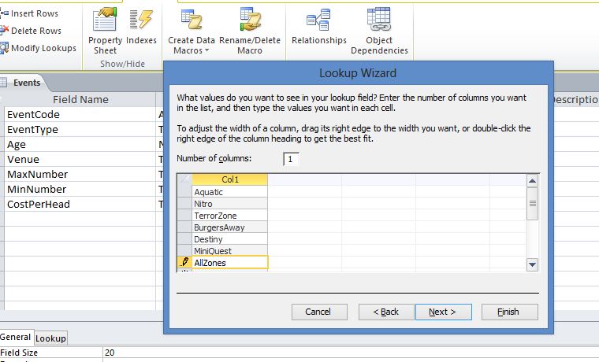

Table 2
Staff
Field Name | Data Type | Length/Format
StaffID | Text | 4
FirstName | Text | 50
Surname | Text | 50

Table 3
Customer
Field Name |  | Data Type |  | Length/Format
CustomerID | Text |  | 7
First Name | Text |  | 20
Surname | Text |  | 20
Address | Text |  | 50
Town | Text |  | 15
Postcode | Numeric |  | 4
Tel No | Text |  | 10

The final table
There are three fields in this table which are linked to the first three tables. When you create the fields you select lookup wizard from the drop down list under data type. This time you choose the top option, click next and then choose the table with the field you want. Then move that field over and press OK.

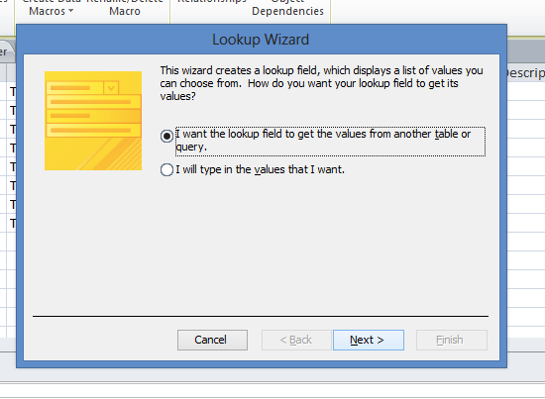

Bookings
Field Name | Data Type | Length/Format
BookingID | Text | 5
CustomerID | Linked to Cust table | link
Date | Date/Time | dd/mm/yy
EventID | Linked to Event table | link
Guests | Numeric | Integer
Arrival Time | Date/Time | hh:mm
Deposit Paid | Currency | $ sign 2 d.p
StaffID | Linked to Staff table | link

Close all the tables

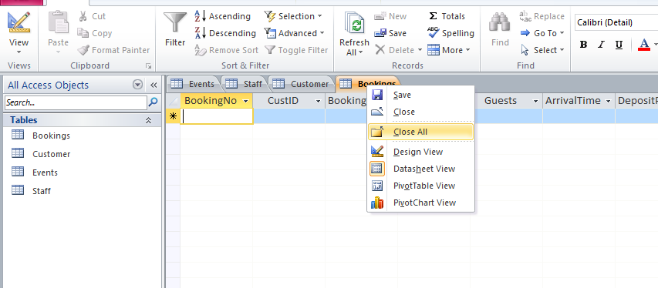

Creating the Relational Database

Use the details below to complete the setup of your relational database.

A Link between the two tables is important so that information can be found from either table or from both. These searches allow the Co-ordinator to make many decisions based on the information and prevent problems of overbooking. Set up the Relationship for the Co-ordinator.

Go to Database Tools and click on relationships, your screen should look like the one below.

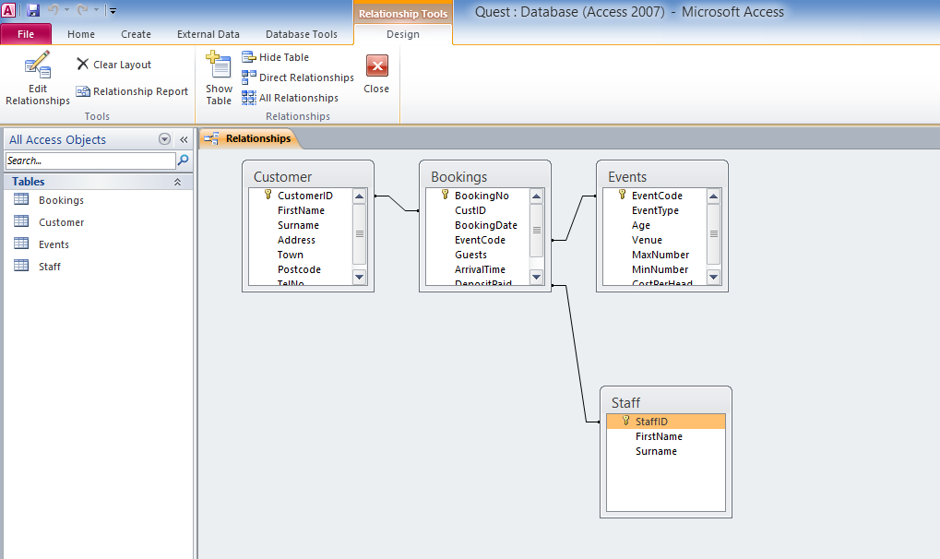

Double click on the line linking two tables. When the Edit Relationships box comes up, tick the box that says Enforce Referential Integrity and OK.

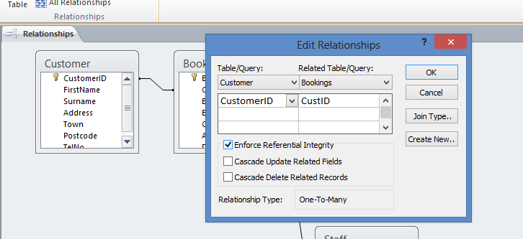

Do this for each link until your tables look like below. Then close and save.

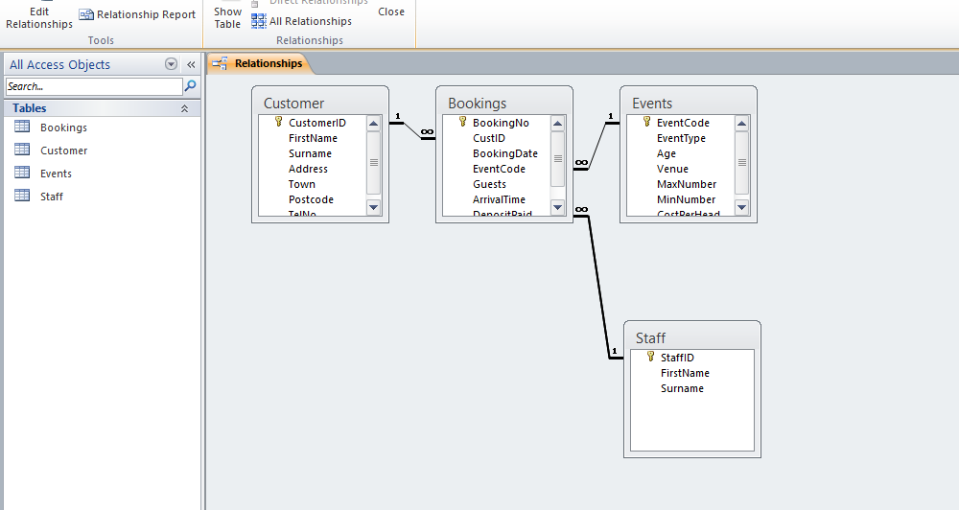

Creating a Form / Data Dashboard

Your Co-ordinator wants to make adding new records easier and feels that creating a form on which this data can be entered would be useful to those people who are not familiar with a database. It is therefore your job to set up a form that can be used by other staff easily. Forms are created using a wizard. You will need a form for each table so that new data could be added easily.

Entering the data

The Theme Park Co-ordinator has asked you to complete the forms using the data for the events and bookings taken so far. This information is listed below.

EVENTS
EventID | Event Type | Age | Venue | Max Number | Min Number | Cost Per Head
18A | 18th Party | adult | Aquatica | 100 | 50 | 15
18N | 18th Party | adult | Nitro | 150 | 50 | 35
18T | 18th Party | adult | Terror Zone | 100 | 50 | 15
BAA | Birthday | adult | Aquatica | 50 | 20 | 20
BAT | Birthday | adult | Terror Zone | 40 | 20 | 20
BKB | Birthday | kids | Burgers Away | 15 | 8 | 6
BKD | Birthday | kids | Destiny | 30 | 10 | 6
BKQ | Birthday | kids | Mini Quest | 40 | 20 | 10
BTA | Birthday | teens | Aquatica | 50 | 20 | 20
BTD | Birthday | teens | Destiny | 20 | 10 | 10
BTT | Birthday | teens | Terror Zone | 40 | 20 | 20
DAN | Disco | adult | Nitro | 300 | 150 | 5
DKA | Disco | kids | Aquatica | 200 | 100 | 1
DTN | Disco | teens | Nitro | 300 | 150 | 5
HAT | Hen Night | adult | Terror Zone | 30 | 10 | 15
MCZ | Mega Party - company | adult | All Zones | 300 | 150 | 10
MFZ | Mega Party - family | all | All Zones | 300 | 150 | 10
PKA | Party | kids | Aquatica | 200 | 20 | .50
PKQ | Party | kids | Mini Quest | 40 | 20 | 10
SAT | Stag Night | adult | Terror Zone | 40 | 20 | 15
WCN | Wedding Cabaret | adult | Nitro | 200 | 100 | 35
WDN | Wedding Disco | adult | Nitro | 300 | 150 | 15

BOOKINGS
BookingID | CustomerID | Date | EventID | Guests | Arrival Time | Deposit Paid | StaffID
B12 | 0009FEL | 08/10/24 | 18N | 75 | 20:00 | 150 | ST1
B2234 | 0005MAR | 03/09/24 | BAT | 40 | 15:00 | 100 | SJ1
B2324 | 0010LAR | 08/05/24 | BKQ | 25 | 15:30 | 50 | MP1
B3246 | 0003JAQ | 27/08/24 | MFZ | 200 | 20:00 | 500 | LA1
B3532 | 0002POT | 06/07/24 | PKA | 24 | 16:00 | 50 | ST1
B4353 | 0002POT | 07/05/24 | WDN | 100 | 20:00 | 100 | SR1
B4354 | 0001FER | 15/09/24 | SAT | 30 | 20:00 | 250 | EJ1
B4422 | 0011LIT | 30/09/24 | BKD | 10 | 16:00 | 25 | SR1
B5858 | 0006JAS | 01/08/24 | BKQ | 10 | 14:30 | 25 | BR1
B6535 | 0008XAV | 05/04/24 | WDN | 150 | 20:00 | 400 | MP1
B7610 | 0013MCE | 07/05/24 | BKQ | 30 | 15:00 | 60 | LA1
B8943 | 0007PRE | 05/07/24 | PKA | 180 | 19:00 | 100 | EJ1
B8944 | 0007PRE | 05/07/24 | DKA | 180 | 20:00 | 100 | AM1
B8977 | 0002POT | 03/02/24 | WCN | 175 | 20:30 | 500 | EJ1
B9190 | 0014BAK | 27/04/24 | PKA | 40 | 15:00 | 100 | SJ1
B9191 | 0004SMI | 14/06/24 | DTN | 250 | 19:00 | 300 | PU1
B9423 | 0006JAS | 08/10/24 | HAT | 50 | 20:30 | 150 | EJ1
B9768 | 0003JAQ | 08/09/24 | BKD | 10 | 14:00 | 25 | BR1
B9999 | 0001FER | 08/05/24 | WCN | 70 | 19:30 | 500 | AK1

.

STAFF
First Name | Surname | Staff ID:
Imran | Zarn | AK1
Daniel | Joseph | AM1
Hanna | Ashworth | BR1
Edward | Franks | EJ1
Liu | Wang | LA1
Tom | Mendell | MP1
Jane | Rovelli | PU1
Peter | Nixon | SJ1
Annette | McKenna | SR1
Paul | Devon | ST1

CUSTOMER
Cust Id: | First Name | Surname | Address | Town | Post Code | Tel No:
0001FER | Vijay | Artez | 5 hendon Valley Road | Hazelworth | 2234 | 0299706876
0002POT | Henry | Steel | 5 Parker Avenue | Broughton | 2567 | 0401706216
0003JAQ | Lino | Feuer | 39 Blaeshill Avenue | Whiteport | 2456 | 0401706366
0004SMI | Pat | Walker | 35 Broughton Road | Hazelworth | 2234 | 0401706033
0005MAR | Paul | Wong | 39 Lindesfarne Street | Whiteport | 2456 | 0299706893
0006JAS | Sue | Birstall | 13 South Headingle | Ramsbury | 2564 | 0401706607
0007PRE | Martin | Batista | 53 Springfield Street | Whiteport | 2456 | 0401706350
0008XAV | Patricia | Heriot | 5 Williams Road | Hazelworth | 2234 | 0299706708
0009FEL | Ana | Accorti | 1 Kirkowen Drive | Hazelworth | 2234 | 0401706340
0010LAR | Paula | Devon | 66 Bland Street | Hazelworth | 2234 | 0299706922
0011LIT | Paul | Domingo | 19 Tower View Street | Whiteport | 2456 | 0299706096
00CAL | Laurence | Bennett | 4 School Syke | Whiteport | 2456 | 0401706533
0013MCE | Ann | Chang | Springfield Hunslett | Ramsbury | 2564 | 0291706601
0014BAK | Luke | Pipps | 3 Hill Crescent | Broughton | 2567 | 0296706173
0015HAN | Francisco | Brown | 71 Devon Road | Ramsbury | 2564 | 0401706969
0016LED | Anita | Ibsen | Heather Helridge | Hazelworth | 2234 | 0401706939
0017SWR | Jaime | Latimer | 3 Forth Avenue | Ramsbury | 2564 | 0291706211
0018JSP | Marie | Nixon | 9 Duncombe Crescent | Broughton | 2567 | 0417065256
0019LIT | Sean | Obrien | 1 Manor Street | Hazelworth | 2234 | 0451706513
0020QKZ | Bernard | Phillipps | 59a Boyd Street | Whiteport | 2456 | 0461706490

Exercises for the Task

Check your tables against the lists to ensure your work is accurate.
This is called Verification. All work that you submit will be in a Word document with a title and your name in a Footer.

You will need to read the mark scheme and ensure you have an introduction to the project included.

1 Screenshots of the following fully annotated in a Word document with a clear title:
  - Screen shots of Design Views (these are called data dictionaries)
  - Screen Shot of the Relationship you created
  - One example of a completed Form from – Bookings Table – called frmBookings
  - One example of a completed Form from – Events Table – called frmEvents
  - One example of a completed Form from – Customers – called frmCustomers
  - One example of a completed Form from – Staff Table – called frmStaff
  - Events Table – called tblEvents
  - Bookings Table – called tblBookings
  - Customers Table – called tblCustomers
  - Staff Table – called tblStaff

This task you should have completed while setting up the database.

2 Sort the Events Table by Cost per Head in Descending Order and Venue in Ascending Order. Screenshot the results and add it to your Word document, annotate.

3 The Co-ordinator has requested a list of all the events being held in the Terror Zone. Create a query, screenshot and include in your Word document, fully annotated.

4 All the events that hold at least 50 people and cost less than $30.00 per head is needed by the Co-ordinator as he has received an enquiry from a potential customer.

Creating business like and professional finishes is also an important part of using information effectively in business. It would not look good if information is not presentable. The Co-ordinator has requested that in future you provide him with answers to his enquiries in an easy-to-understand format. The best way to present this information is in a Report.

Screenshot the report and include in your Word document fully annotated.

5 The Co-ordinator needs to take the information about the events holding at least 50 people to a potential customer, so it is important that it looks professional and is not just a table of information. Create a Report for him to discuss the options with the customer. You should screenshot your results and include them in the Word document.

6 The Co-ordinator has requested a report on all the bookings made for the 7th and 8th May 2012 as he is considering holding a major exhibition the first week of May and has to consider who is likely to be affected. Carry out the query and produce the report.

7. Query all bookings for birthdays for kids. The Co-ordinator only wants to know these fields:
BookingID
Date of Event
EventID
Time of Arrival
Create a report of these details called rptBirthdaysForKids.

8. The Co-ordinator needs to check which staff have been allocated to the Terror Zone. She needs to know:
BookingID, Date, CustomerID, FirstName, Surname, EventID, Venue, StaffID
Of course she will expect this information presented in a professional format.

9. A Customer Service query has just come through. Mr Luke Pipps has lost his customer details and needs to know the following:
His CustomerID
The Date of his Booking
The number of Guests he has booked for
The time he can arrive
The name of the Venue
Who is the member of staff to whom he should report to?

Find all the required details to answer this query.
Print out in a professional format the details Mr Pipps will require posting out to him and his address details will need to be printed on a label.

10. Make sure you have included screenshots of all your work fully annotated in your Word document.
It is important that you have your system checked by a different user before you leave the database for others to use in case there are any errors. Ask a different person to check your system is easy to use.

Design a questionnaire that they can complete which asks how useful your database is for the company. Would they recommend any improvements?

Evaluate your work.
Did you complete all the tasks effectively?
How easy do you find your database to use?
How easy was it for someone else to use?
Would you change your database in any way to improve it?

